

Indonesian Journal of Science & Technology x(x) (20xx) x-xx

Indonesian Journal of Science & Technology
Journal homepage: http://ejournal.upi.edu/index.php/ijost/

Integration of Public Electric Vehicle Charging Stations Into a Single Gateway Platform for Net Zero Emissions (NZE) Goals

Fajar Sidiq Arrizal*, Shafira Febriani
STMIK AMIKBANDUNG, Bandung, Indonesia
*Correspondence: E-mail: f.arrizal36@gmail.com
A B S T R A C T |  | A R T I C L E I N F O
The development of electric vehicles in Indonesia has been accelerating in line with increasing awareness of environmentally friendly energy and carbon emission reduction. One of the main challenges is the lack of real-time information regarding Public Electric Vehicle Charging Stations (SPKLU). This study aims to develop a web-based system, the Single Gateway, that can display the real-time usage status of SPKLU and help users locate the nearest station based on their current location. This research adopts methods including literature review, system analysis, design, implementation, testing, and evaluation. The system integrates national SPKLU data and provides access to several key operational parameters. The results show: (1) SPKLU availability status can be displayed through the station detail menu; (2) electricity consumption in June reached 3,548,943.928 kWh; (3) carbon emissions for June totaled 2,748,262.774 kgCO₂eq; (4) the margin of error for connector status is around 10%; and (5) the average SPKLU usage duration is 2 hours 14 minutes 44 seconds. This system is expected to encourage broader adoption of electric vehicles by providing transparent and accessible SPKLU information.  © 2025 Tim Pengembang Jurnal UPI |  | Article History:  Submitted/Received 00 xxx 2021  First Revised 00 xxx 2021  Accepted 00 xxx 2021  First Available Online 00 xxx 2021  Publication Date 00 xxx 2021  ____________________  Keyword:  EV Charging Station,  Single Gateway,  Data Integration,  Real-Time Monitoring,  Carbon Emission.

1. INTRODUCTION

The adoption of electric vehicles (EVs) in Indonesia has risen sharply in recent years, with national wholesale sales growing from 17,051 units in 2023 to 30,400 units in 2024, reflecting approximately 78% growth year-over-year [1, 2]. This development underscores the urgent need for supporting infrastructure—particularly Public Electric Vehicle Charging Stations (SPKLU)—which are essential not only for enabling widespread EV usage, but also for achieving the national goal of Net Zero Emission (NZE) as mandated by Presidential Regulation No. 55 of 2019 [3].
Globally, EV adoption continues to accelerate. In 2023, nearly 14 million new electric cars were registered, a 35% increase compared to 2022 [4]. However, charging infrastructure has not grown at the same pace. A systematic review shows that global charging infrastructure demand remains a key barrier to EV expansion [5]. This challenge is also evident in Indonesia, where most SPKLUs are concentrated in Java while other regions remain underserved, creating accessibility gaps [6].
Studies estimate that to meet its 2030 EV targets, Indonesia must significantly expand both fast-charging and slow-charging infrastructure [7, 8]. For instance, projections from ICCT suggest that tens of thousands of charging points are required by 2030 to support passenger EVs [9]. Similarly, analysis from academic and industry reports indicates that business feasibility, regulation, and consumer readiness still limit large-scale deployment [10, 11].
Recent surveys also highlight uneven consumer perception and adoption rates across Indonesia, where urban areas demand optimized charging placement to mitigate range anxiety [12]. Case studies in Yogyakarta and Jakarta demonstrate that location optimization is critical to ensure accessibility and efficiency [13]. Furthermore, simulation models suggest that infrastructure deployment strategies must consider regional variations in demand to avoid bottlenecks [14, 15].
Fragmentation in platform operations further complicates matters: each business entity managing SPKLUs operates its own system and application, forcing EV drivers to install multiple apps, while also reducing transparency in electricity consumption and emission monitoring [6], [10]. To address these issues, a centralized integration mechanism is needed. Global literature confirms that integration through Application Programming Interfaces (APIs) enables better scalability, data consistency, and performance monitoring [5, 11].
In this context, this study proposes the Single Gateway system as a centralized digital platform that integrates SPKLU operational data from multiple business entities via APIs. The system is implemented using Laravel for the backend and Vue.js for the frontend, selected for their scalability and suitability for real-time synchronization. With this integration, users, operators, and regulators gain access to real-time information on station availability, electricity consumption, and estimated carbon emission reductions. This unified visibility is expected to strengthen monitoring, support policy formulation, improve operational efficiency, and accelerate Indonesia’s trajectory toward its NZE objectives.
2. METHODS
This study applied a waterfall methodology, consisting of literature review, system analysis, design, implementation, testing, and evaluation. The system was developed using Laravel for the back-end, Vue.js for the front-end, and PostgreSQL as the database. Business entities submitted operational SPKLU data through API endpoints, including station status and electricity consumption. Carbon emissions were estimated using the Indonesian electricity emission factor of 0,774388897 kgCO₂eq per kWh [14].

2.1. Integration Concept
The idea is to receive data from each business entity that manage SPKLU to send their transaction data to Single Gateway so that every SPKLU in Indonesia is centralized in a single platform. There are possibilities that every business entity use a different OCPP or even using a different protocol. To make a single centralized platform we need to standarize the data transaction between Single Gateway with business entity’s application. To standarize the data we use API with JSON so that every business entity could send their transaction data. First business entity need to login to Single Gateway platform then access the integration menu. After that they can propose an integration application which need to be review and verified by the government. After the government accept the application business entity will receive API documentation and credential to hit the API which used to determine which business entity is currently hit the API. Later each business entity expect to consume the API and set a code send their transaction data continously.
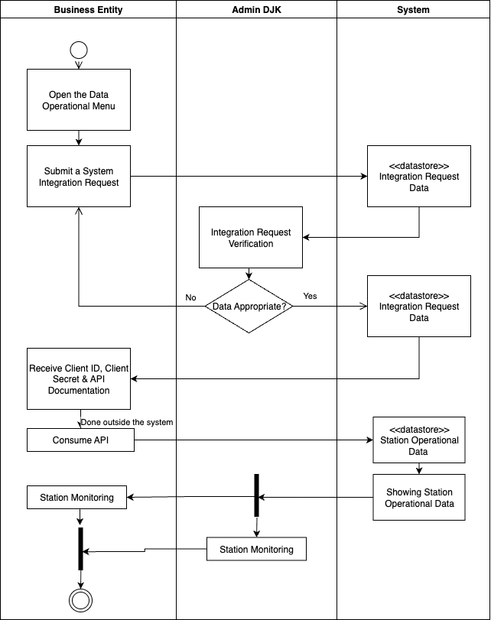
Figure 1. Integration Concept
2.2. User Interface
To propose an integration application each business entity need to submit the following documents such as Application letter, Software Requirement Specification (SRS), and Vulnerability Assessment (VA). After the proposal accepted business entity will get their credential whish is a client ID and client secret also they can download the API documentation file. After they get those information, each business entity are expected to send their transaction data continously.
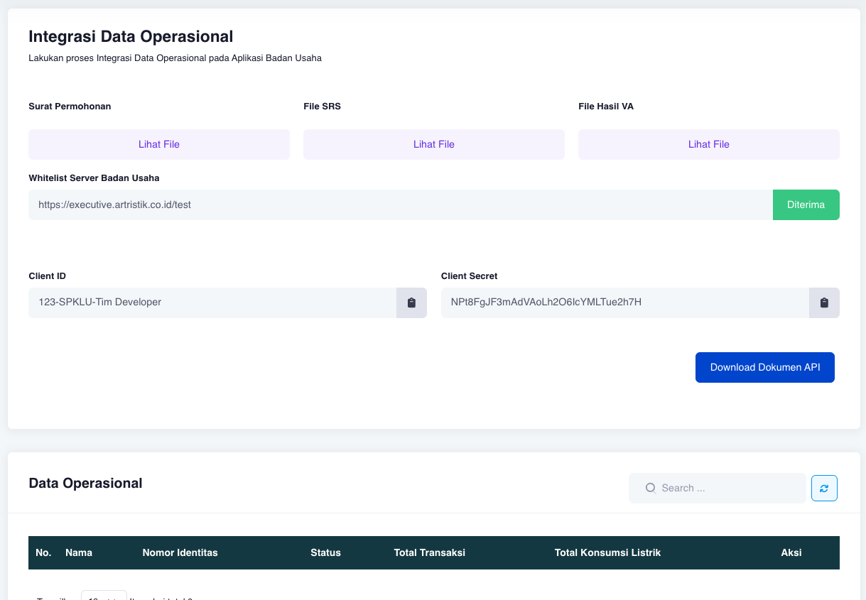
Figure 2. Whitelist Application Page

2.3. Data Collection
Data for this study were collected from SPKLU operators and integrated into the Single Gateway through API submission. The testing and analysis were limited to operational data recorded in June 2025. In addition, the integration experiment was carried out on 10 SPKLU locations in Bandung and Central Jakarta, accounting for about 12% of the total stations in these cities.

3. RESULTS AND DISCUSSION
3.1. Integration Testing
To evaluate the accuracy of the Single Gateway platform, integration testing was conducted using sample data from 10 charging stations located in Bandung and Central Jakarta, representing 20 connectors in total. The status of each connector in the Single Gateway system was compared with the status displayed in the business entities’ applications.

Table 1. SPKLU Status Comparison
No. | Nama Stasiun | Status in Single Gateway | Status in business entity’s app
1 | SPKLU PLN ULP Kopo | Available | Available
2 | SPKLU PLN Geowisata Inn | Available 2 | Available 2
3 | SPKLU PLN UID Jawa Barat | Charging | Charging
4 | SPKLU PLN ICON HUB (BRAGA HERITAGE) | Charging 2, available 2 | Charging 2, available 2
5 | SPKLU Posko Yantek Samratulangi UP3 Menteng | Charging, available | Available, available
6 | SPKLU MENARA DANAREKSA | Available 2 | Available 2
7 | SPKLU Utomo Charge+ Plaza Galeon | Unavailable 2 | Not available 2
8 | SPKLU Area Parkir Urban Forest | Available,charging | Charging 2
9 | SPKLU GRAHA MITRA | Available,charging | Available, charging
10 | SPKLU BALAI KOTA BANDUNG | Available 2 | Available 2

Based on the data in Table 1, there were 20 connectors tested. The margin of error (MoE) was calculated using the following formula:
$$Margin of Error (\%)= \left(\frac{Total konektor tidak sesuai}{Total konektor}\right)× 100$$ | (1)
In this case, 2 out of 20 connectors showed inconsistent status between the Single Gateway and business entities’ applications:
$$Margin of Error= \left(\frac{2}{20}\right)× 100=10 \%$$
Thus, the margin of error for integration testing was 10%, which is considered acceptable for real-time synchronization given possible delays in data submission or incomplete reporting by business entities.

3.2. Transaction Logs and Station Detail Page
After each company sends their transaction data continously below is an example of the log that has been sent to Single Gateway. Figure 3 shows the electricity transactions and consumption page, which displays historical data related to electric vehicle charging transactions, including electricity consumption, income, and transaction status. The data is displayed in an easy-to-read and searchable table format. The electricity consumption sent to the Single Gateway is only the kWh used per transaction. Income is optional, as it's conventional data, so businesses can send it or not. Status is mandatory to determine the status of the connector. Also here’s the view of corresponding integrated station.
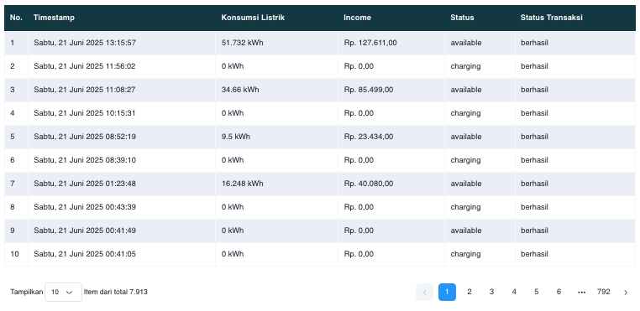
Figure 3. Log Transaction of Integrated Station
After the Business Entity integrates the Charging station with the Single Gateway, the availability status will be visible in the detail page, as shown in Figure 4. The connector availability status will be displayed as available, unavailable, charging, or finishing. In addition to the connector availability status, the connector type will also be displayed.
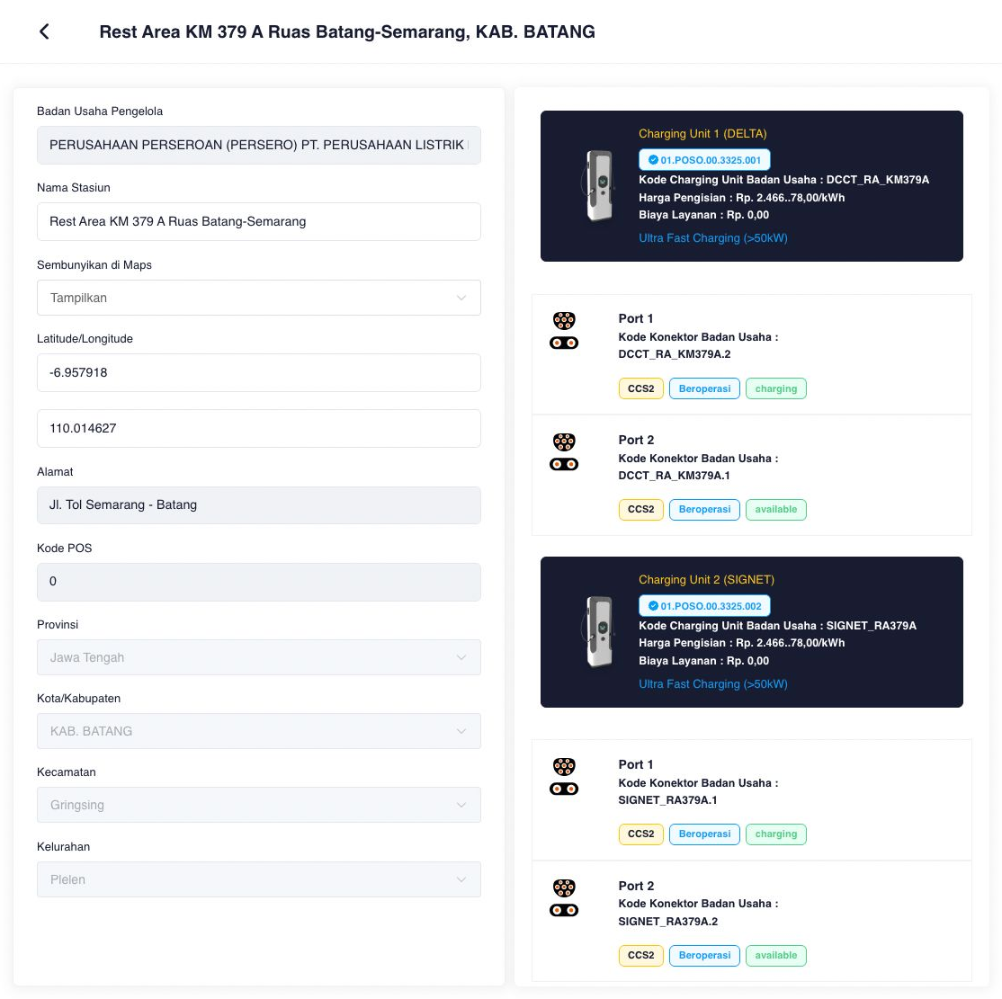
Figure 4. Detail page of Integrated Station

3.3. Electricity Consumption and Carbon Emission Estimation
Electricity consumption data were collected for June 2025 from the integrated SPKLU network through the Single Gateway platform. Daily consumption records were obtained from business entities and aggregated into monthly totals. The summary of monthly electricity consumption, emission factor, and estimated carbon emissions is presented in Figure 5, which shows that the total electricity consumption in June 2025 reached 3,548,943.928 kWh, equivalent to an estimated 2,748,262.774 kgCO₂eq.
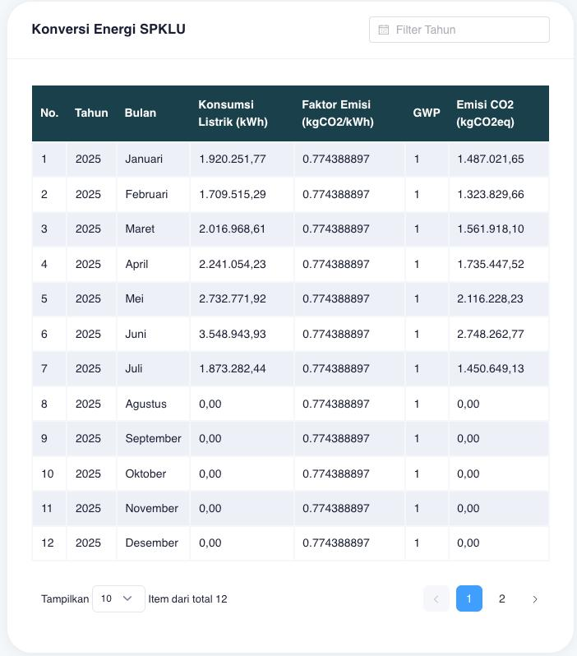
Figure 5. Monthly Electricity Consumption and Estimated Carbon Emmision from SPKLU in 2025
The data indicate that electricity usage and corresponding emissions vary each month, with June 2025 showing the highest recorded consumption. This reflects fluctuations in charging demand and station availability, while also demonstrating the ability of the integrated system to consolidate operational and environmental information. These results confirm that the API-based integration not only facilitates operational monitoring but also provides reliable data for evaluating environmental benefits, particularly in the context of the Net Zero Emission (NZE) program.
4. CONCLUSION

This research successfully developed and tested an integration system through an Application Programming Interface (API) that functions as intended. The system, implemented as a web-based Single Gateway using PHP (Laravel) and Vue.js, enables the real-time display of SPKLU availability and requires consistent data submission from business entities to ensure accuracy. Testing results showed that SPKLU electricity consumption in June 2025 reached 3,548,943.928 kWh, which corresponded to a carbon emission reduction of 2,748,262.774 kgCO₂eq based on the applied calculation formula. The findings also revealed an approximate 10% margin of error in integrated connector status, likely caused by delayed or missing data submissions from business entity applications. In summary, the developed platform not only provides real-time availability information but also delivers operational insights related to energy consumption and emission reduction. This integration is expected to enhance transparency, facilitate monitoring, and support decision-making processes for stakeholders involved in managing and developing SPKLU infrastructure.
5. AUTHORS’ NOTE

The authors declare that there is no conflict of interest regarding the publication of this article. The authors confirmed that the paper was free of plagiarism.
6. REFERENCES

[1] International Institute for Sustainable Development (IISD), “The Indonesian Electric Vehicle Boom: Temporary Trend or Long-Term Vision?,” IISD Reports, 2023. [Online]. Available: https://www.iisd.org/articles/deep-dive/indonesian-electric-vehicle-boom-temporary-trend-or-long-term-vision
[2] International Energy Agency (IEA), “Global EV Outlook 2024 – Trends in electric cars,” IEA Report, 2024. [Online]. Available: https://www.iea.org/reports/global-ev-outlook-2024/trends-in-electric-cars
[3] Government of Indonesia, “Presidential Regulation No. 55 of 2019: Acceleration of Battery Electric Vehicle Program,” Official Gazette of Indonesia, 2019.
[4] International Energy Agency (IEA), “Net Zero by 2050: A Roadmap for the Global Energy Sector,” IEA Special Report, 2021. [Online]. Available: https://www.iea.org/reports/net-zero-by-2050
[5] M. Xylia, E. Olsson, B. Macura, and B. Nykvist, “Estimating charging infrastructure demand for electric vehicles: a systematic review,” Energy Strategy Reviews, vol. 59, p. 101753, 2025. [Online]. Available: https://doi.org/10.1016/j.esr.2025.101753
[6] M. D. Ramadhani, et al., “Development of Electric Vehicle Charging Infrastructure in Indonesia to Achieve the Target of Nationally Determined Contribution by 2030,” Jurnal Energi dan Lingkungan, vol. 9, no. 1, pp. 45–56, 2023. [Online]. Available: https://doi.org/10.36982/jeg.v9i1.3965
[7] H. Zhang, et al., “Charging Indonesia’s Vehicle Transition: Infrastructure needs for electric passenger cars in 2030,” The International Council on Clean Transportation (ICCT), 2024. [Online]. Available: https://theicct.org/wp-content/uploads/2024/02/ID-88-%E2%80%93-Indonesia-charging_final2.pdf
[8] H. Basmantra, “A Comprehensive Analysis of the Economic Implications, Challenges, and Opportunities of Electric Vehicle Adoption in Indonesia,” Energies, vol. 18, no. 6, p. 1384, 2025. [Online]. Available: https://doi.org/10.3390/en18061384
[9] A. Pratama and R. Wahyudi, “How the Adoption of EVs in Developing Countries Can Be Accelerated,” World Electric Vehicle Journal, vol. 16, no. 8, p. 428, 2025. [Online]. Available: https://doi.org/10.3390/wevj16080428
[10] PwC Indonesia, “Road Ahead: Indonesia’s Electric Vehicle Readiness and Consumer Insights 2024,” PwC Report, 2024. [Online]. Available: https://www.pwc.com/id/en/publications/automotive/indonesia-electric-vehicle-readiness-consumer-insights-2024.pdf
[11] R. Kurniawan and T. Santoso, “Business Feasibility of Charging Infrastructure to Increase EV Adoption in Indonesia,” Jurnal Industri Petra, vol. 23, no. 2, pp. 112–121, 2023. [Online]. Available: https://jurnalindustri.petra.ac.id/index.php/ind/article/view/27005
[12] S. Hidayat, et al., “Designing an Optimized Electric Vehicle Charging Station Infrastructure for Urban Area: A Case Study from Indonesia,” arXiv preprint, 2022. [Online]. Available: https://arxiv.org/abs/2209.03448
[13] F. Zhang, et al., “Electric Vehicle Adoption in Indonesia: Lessons Learned and Policy Recommendations,” Journal of Cleaner Production, vol. 412, p. 137895, 2024. [Online]. Available: https://www.sciencedirect.com/science/article/pii/S2666188824001977
[14] Ecometrica, “Emission Factors for Grid Electricity,” Ecometrica Report, 2024. [Online]. Available: https://ecometrica.com
[15] R. I. Nugroho, et al., “Designing optimal fast-charging infrastructure for various deployment scenarios in Indonesia,” Sustainable Energy Systems, vol. 5, no. 2, 2025. [Online]. Available:

